MSD_Logo_2015.eps

Louisville/Jefferson County MSD

Annual Budgets

Adopted May 24, 2021

Fiscal Year Starting July 1, 2021

Table of Contents

[Blueprint 2025 2](#_Toc72763243)

[Executive Director’s Message 4](#_Toc72763244)

[2022 Annual Budget Executive Summary 5](#_Toc72763245)

[Operating Budget Summary 6](#_Toc72763246)

[Fiscal Year 2022 Operating Revenue 7](#_Toc72763247)

[Wastewater & Stormwater Service Charges 7](#_Toc72763248)

[Rate Increase History 7](#_Toc72763249)

[Customer Affordability 8](#_Toc72763250)

[Average Residential Bill 9](#_Toc72763251)

[Rate Comparability 10](#_Toc72763252)

[Fiscal Year 2022 Operating and Maintenance Expenses 11](#_Toc72763253)

[Operating & Maintenance Expense Summary 11](#_Toc72763254)

[Operating & Maintenance Expenses by Division 12](#_Toc72763255)

[Administration Division Operating Expense Budget 13](#_Toc72763256)

[Corporate Division Operating Expense Budget 14](#_Toc72763257)

[Engineering Division Operating Expense Budget 15](#_Toc72763258)

[Finance Division Operating Expense Budget 16](#_Toc72763259)

[Human Resources Division Operating Expense Budget 17](#_Toc72763260)

[Information Technology Division Operating Expense Budget 18](#_Toc72763261)

[Legal Division Operating Expense Budget 19](#_Toc72763262)

[Operations Division Operating Expense Budget 20](#_Toc72763263)

[Supply Chain & Economic Inclusion Division Operating Expense Budget 21](#_Toc72763264)

[Headcount 22](#_Toc72763265)

[Fiscal Year 2022 Non-Operating Income and Expenses 23](#_Toc72763266)

[Fiscal Year 2022 Capital Budget 23](#_Toc72763267)

[Ratios 24](#_Toc72763268)

[Ten Year Outlook 25](#_Toc72763270)

[Debt Management 26](#_Toc72763271)

# Blueprint 2025

Blueprint 2025 is our action plan to transform MSD into the Utility of the Future by the year 2025. MSD establishes annual performance goals that are in alignment with Blueprint 2025. Each goal category has two focus areas: a) business activities critical to the attainment of the goal category desired outcome and (b) strategic transformational initiatives designed to enhance the attainment of each critical success factor. Individual goals and transformational initiatives are established for management of the operating and capital budgets as part of critical success factor 4, Ensure Financial Stewardship and Sustainability of Community Resources.

Management of the operating budget is achieved through monthly financial reporting and expense review by the management team of each division. On a quarterly basis, division managers meet with the Executive Director, Chief Financial Officer and the Budget & Financial Reporting Manager to review budget variances, discuss adaptive management practices and develop forecasts for the remainder of the year.

Management of the capital budget is achieved by tracking program execution and closely monitoring project delivery, risk management and performance against the approved budget. Capital project managers meet monthly with Program Controls staff to update project status. Variances are moved forward for management review culminating in a monthly Capital Improvement Program (CIP) Management Team meeting which facilitates collaboration and adaptive management of the program.

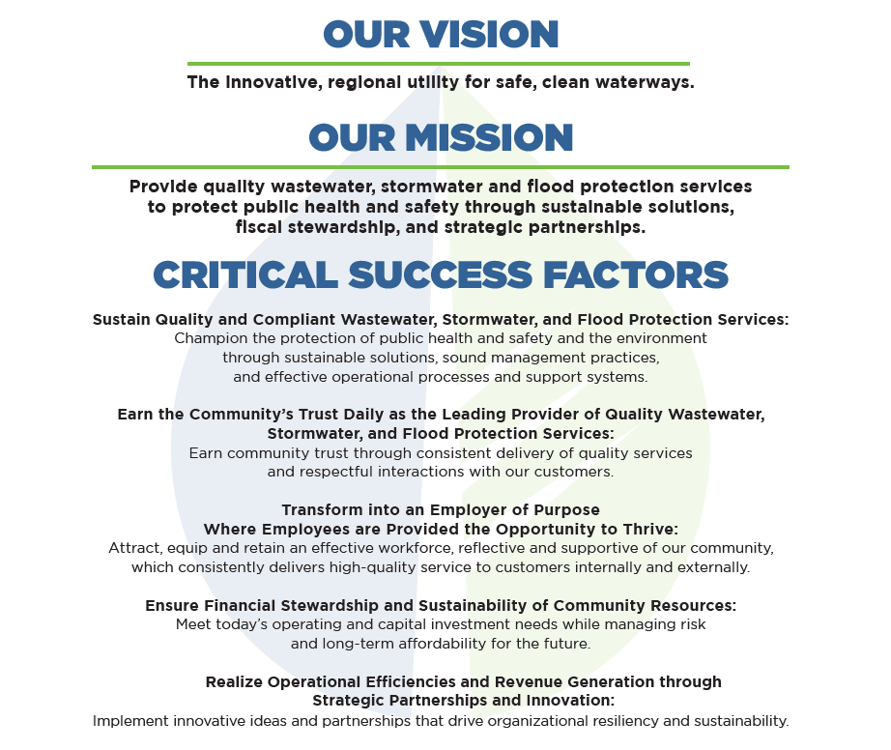

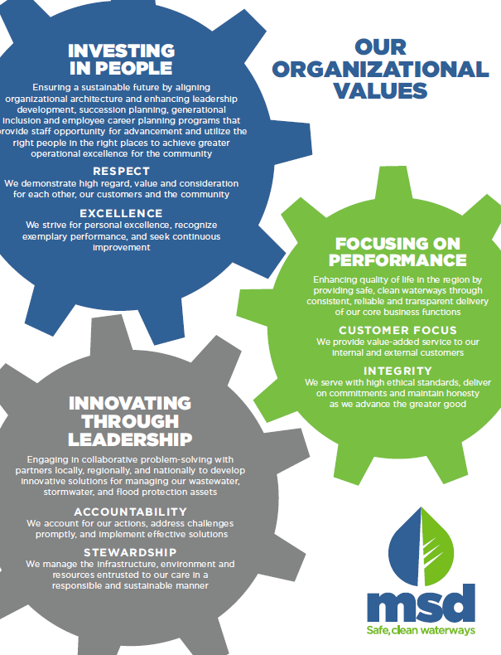

# Executive Director’s Message

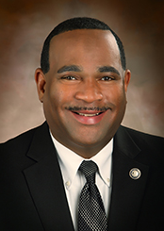

Louisville MSD is committed to achieving our mission of safe, clean waterways. The vital services we provide through collecting and treating wastewater, flood protection, and managing stormwater are essential for our community's health and safety and its economic vitality.

In the coming fiscal year, MSD will invest more than $200 million in capital improvement projects. One of our most significant infrastructure improvement projects, the Waterway Protection Tunnel, will near completion at the end of 2022. We are leveraging grants and innovative loans for the critical work to replace the outdated biosolids processing at Morris Forman Water Quality Treatment Center and renovating and expanding our Paddy’s Run Flood Pumping Station, built in 1953. Additionally, frequent sewer cave-ins and failures are examples of the challenges we face across the community with outdated infrastructure that is long past its useful life.

On May 24, 2021 the MSD Board voted to approve a preliminary rate change, including a $3.54 increase for monthly wastewater and a $.77 increase for monthly stormwater, totaling a $4.31 monthly increase for the average residential bill. In addition, the Board extended our Emergency Wastewater Rate Assistance Program, EWRAP, launched last year during the COVID-19 pandemic, to help those customers experiencing financial hardships. Under the program, MSD provides a 10 percent discount to ratepayers whose household incomes are at 150 percent of the poverty line or below. EWRAP is in addition to MSD’s existing 30 percent discount on wastewater services for qualified senior citizens.

This year’s rate proposal and budgets will help us maintain our vital facilities that protect the community’s health and safety while also meeting our federal regulatory requirements for environmental protection.

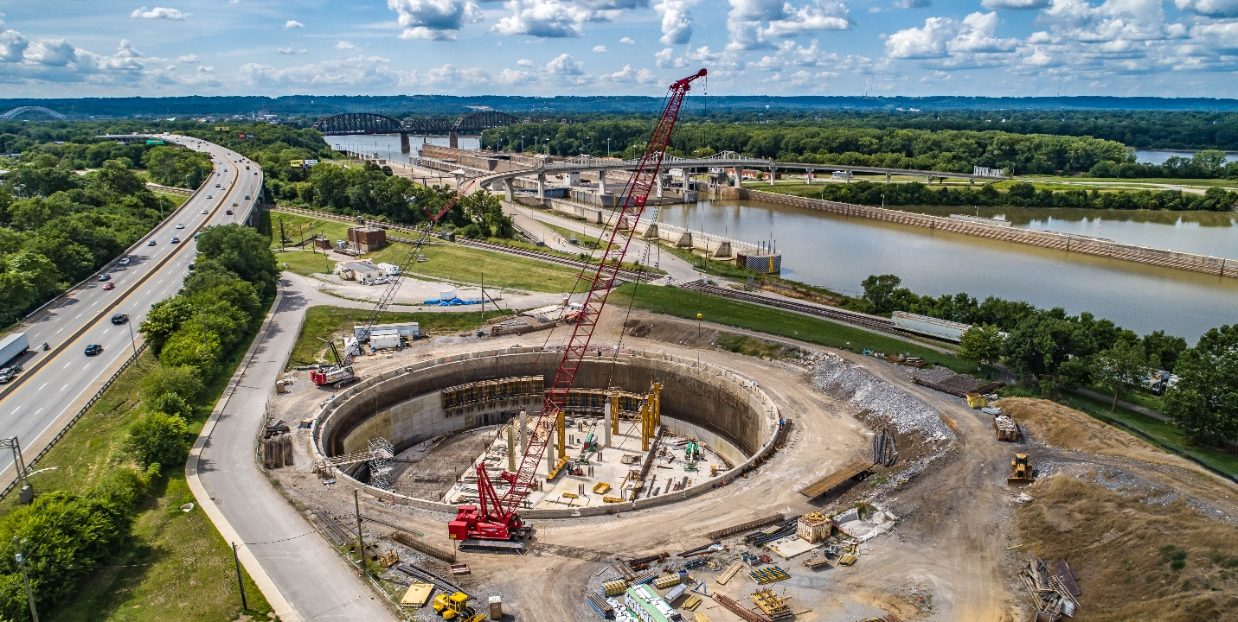

*MSD’s Portland Combined Sewer Overflow Basin*

# 2022 Annual Budget Executive Summary

**Operating Budget**

**Operating Revenue**

**Wastewater** service charges for fiscal year 2022 are budgeted at $255.7 million. Wastewater service charge revenue is 5.6% higher than the fiscal year 2021 forecast as a result of the August 1, 2021 rate increase.

**Stormwater** service charges for fiscal year 2022 are budgeted at $85.2 million. Stormwater service charge revenue is 7.2% higher than the fiscal year 2021 forecast primarily as a result of the August 1, 2021 rate increase.

**Other Revenue** for fiscal year 2022 is budgeted at $4.3 million. Other revenue is 3.4% lower that the FY21 forecast.

**Operating Expense**

**Operating and Maintenance Expense** for fiscal year 2022 is budgeted at $161 million. Operating and Maintenance expense is 5.3% higher than the FY21 forecast due to a combination of funding vacant positions, higher insurance premiums, and increasing operating costs associated with capturing and treating stormwater and wastewater.

**Depreciation and Amortization Expense** for fiscal year 2022 is budgeted at $97 million. Depreciation and Amortization Expense is 0.6% higher than the fiscal year 2021 forecast.

**Non-Operating Income/Expense**

**Interest Income** for fiscal year 2022 is budgeted at $11.5 million. Interest income is 2.7% lower than the fiscal year 2021 forecast due to lower projected returns on MSD’s investment portfolio.

**Interest Expense** for fiscal year 2022 is budgeted at $114.2 million. Interest expense is 26.8% higher than the fiscal year 2021 forecast due to the planned issuance of the 2022A revenue bond that will redeem outstanding commercial paper and the implementation of GASB 89 which eliminates the capitalization of interest cost incurred before the end of a construction period.

**Capital Budget**

**Capital Improvement Plan** for fiscal year 2022 is $200.7 million. The capital improvement plan is 10.5% higher than the fiscal year 2021 forecast due to a combination of spending required under the Integrated Overflow Abatement Plan, the 2nd Amended Consent Decree, state agreed orders, and continued repair, replacement and rehabilitation of existing assets.

# Operating Budget Summary





# Fiscal Year 2022 Operating Revenue

## Wastewater & Stormwater Service Charges

MSD covenants in its Bond Resolution to maintain sufficient revenues to cover the cost of operating its systems, paying its annual debt service and funding a portion of asset repair and rehabilitation costs. Louisville Metro Ordinance §50.24 requires that whenever MSD's net revenues are less than 1.1 times the debt service on MSD's outstanding revenue bonds for any consecutive six-month period, by order of the Board of MSD, the schedule of wastewater and stormwater service charges shall be amended in order to maintain a 1.10 debt service coverage required by MSD's 1971 bond authorizing resolution provided the aggregate of such adjustments for any 12-month period shall not generate additional revenue from wastewater and stormwater service charges in excess of 7%. MSD performs this debt service calculation every year during the rate planning process. For the six month period ending March 31, 2021, the debt service coverage ratio was 0.74. MSD’s Revenue and Collection Manager leads a cross-functional management team each year to recommend updates to the schedule of rates, rentals and charges. These updates are recommended to MSD’s Board in the form of a preliminary rate resolution.

On Monday, May 24, 2021, the MSD Board approved a preliminary rate resolution amending MSD’s 2021 schedule of rates, rentals, and charges. The proposed fiscal year 2022 rate schedule, which was recommended pursuant to the debt service adjustment provisions of §50.24, includes a 6.9% rate increase in wastewater and drainage charges. This rate increase is necessary to produce aggregate revenues to MSD sufficient for the payment of interest on and principal of all revenue bonds and other debt of the District, the expenses of operating and maintaining the sewer and drainage system, and for the payment of capital improvements to the system. The preliminary rate resolution was posted on our website at [LouisvilleMSD.org/Rates](https://louisvillemsd.org/Rates) and notice of the rate increase was published in the Courier Journal on May 30, 2021. MSD will accept written comments until June 30, 2021. Comments from the public will be delivered to the MSD Board on July 26, 2021 at which time the Board will consider final adoption of the preliminary rate resolution.

## Rate Increase History

The following table shows MSD’s rate increase history since 2011 along with the current preliminary rate increase.

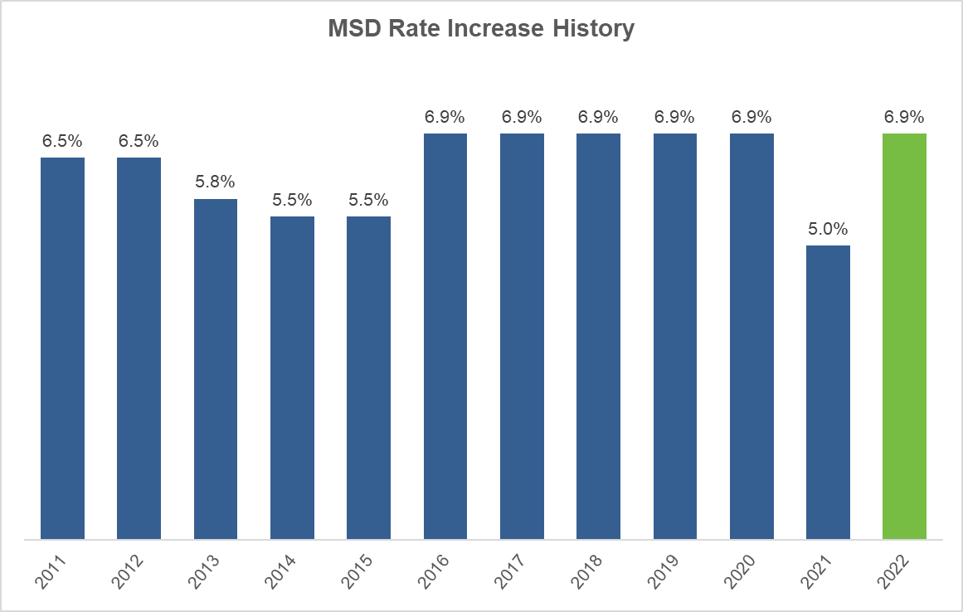

## Customer Affordability

MSD recognizes that the affordability of the essential services it provides is a concern for many. We have implemented the following programs to provide assistance to the most vulnerable in our community. MSD expects to provide over $1,500,000 in total customer assistance in fiscal year 2022.

**EWRAP**

MSD implemented the Emergency Wastewater Rate Assistance Program (EWRAP) on August 1, 2020. EWRAP provides a 10% discount on MSD wastewater services to customers with a total household income at or below 150% of the federal poverty line.

Applications for the EWRAP discount can be made on the Louisville MSD website (louisvillemsd.org). Once a customer is approved, the EWRAP discount will become effective on the next MSD bill generated by the Louisville Water Company. Discounts will continue through July 31, 2022. Applications require household information and income verification.

**Senior Citizens Discount**

MSD offers a Senior Citizens Discount program for customers that are 65 years or older with an annual income of $35,000 or less. Qualifying customers receive a 30% discount on wastewater services. This program provides about $1,000,000 in assistance to qualifying seniors annually. Customers cannot qualify for both the Senior Discount and EWRAP discount.

Applications for the Senior Citizens discount can be made on the Louisville MSD website (louisvillemsd.org). Once a customer is approved, the discount will become effective on the next MSD bill generated by the Louisville Water Company. Applications require household information and income verification. Program participants must re-certify annually.

**Drops of Kindness**

MSD increased its contribution to the Louisville Water Foundation in fiscal year 2020 by $100,000 to $250,000 after the outbreak of COVID-19. MSD provided another $250,000 in contributions to the Louisville Water Foundation in fiscal year 2021. This funding is distributed to the Association of Community Ministries to provide customer bill assistance to families in need. MSD will continue to support this program in fiscal year 2022.

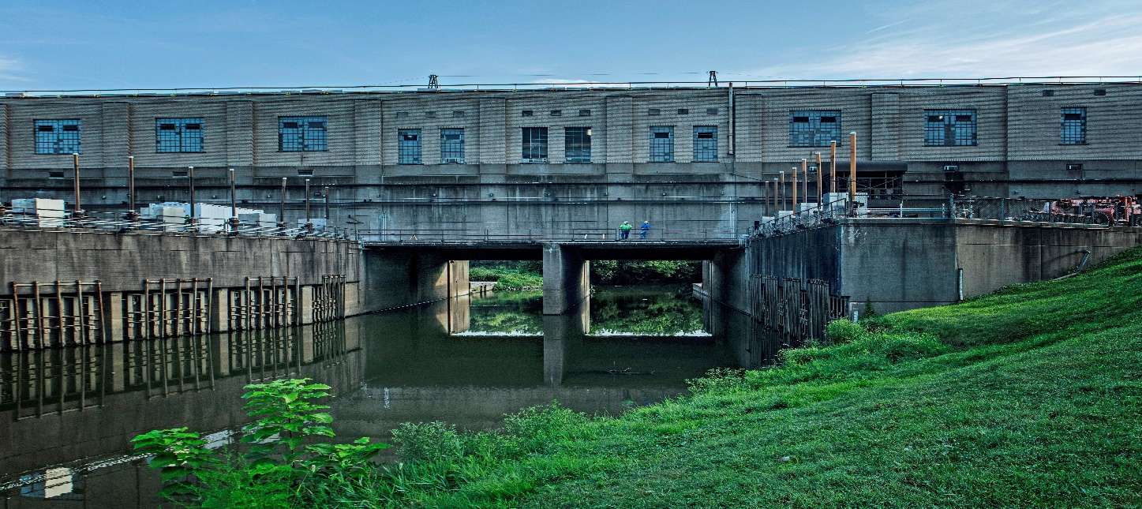Questions about our *customer assistance programs can be directed to* [*revenuegroup@louisvillemsd.org*](mailto:revenuegroup@louisvillemsd.org)*.*

*MSD’s Beargrass Creek Flood Pump Station*

## Average Residential Bill

MSD defines an average residential customer as a single family household that uses 4,000 gallons of water per month. The monthly wastewater bill for the average residential customer will increase on August 1, 2021 from $51.45 to $54.99 or by $3.54. The monthly residential drainage charge will increase from $11.11 to $11.88 or by $0.77. The total monthly increase for the average residential customer is $4.31.

Average residential customers qualifying for the EWRAP discount will receive a credit of $5.50 reducing their monthly bill to $61.37.





## Rate Comparability

The National Association of Clean Water Agencies (NACWA) collects data from around the country on wastewater rates. Based on information collected as of January 1. 2021, MSD’s wastewater rates remain lower than area regional cities including Cincinnati, Indianapolis, Nashville and St. Louis.

NACWA publishes an annual Cost of Clean Water Index. The 2018 Index published on May 19, 2019 found that the average cost of wastewater services in 2018 surpassed the increase in the rate of inflation as measured by the Consumer Price Index (CPI) for the 17th consecutive year. NACWA’s results indicated that for the foreseeable future service charges will continue to increase nationwide as utilities struggle with capital infrastructure requirements, debt financing and aging infrastructure. Additionally, expected increases in operation and maintenance costs as well as regulatory requirements associated with nutrients will continue to drive the total cost to operate wastewater utilities.

## 

*MSD’s Pond Creek Flood Pump Station*

# Fiscal Year 2022 Operating and Maintenance Expenses

## Operating & Maintenance Expense Summary





*MSD’s Waterway Protection Tunnel*

## Operating & Maintenance Expenses by Division



## Administration Division Operating Expense Budget



## Corporate Division Operating Expense Budget



## Engineering Division Operating Expense Budget



## Finance Division Operating Expense Budget



## Human Resources Division Operating Expense Budget



## Information Technology Division Operating Expense Budget

## Legal Division Operating Expense Budget



## Operations Division Operating Expense Budget

## Supply Chain & Economic Inclusion Division Operating Expense Budget

## 

## Headcount



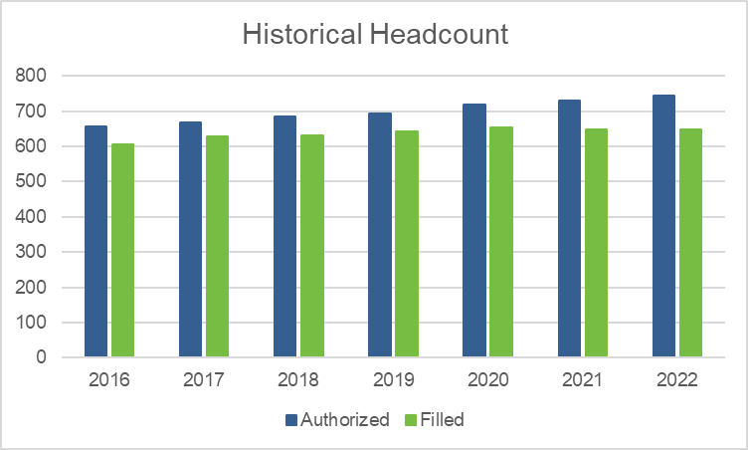

# Fiscal Year 2022 Non-Operating Income and Expenses



# Fiscal Year 2022 Capital Budget

The MSD Board approved a suite of Capital Improvement Program (CIP) projects totaling $200.7 million for fiscal year 2022 on May 24, 2021. The projects included in the fiscal year 2022 CIP fit into MSD’s 5-year CIP. Many projects span multiple years and will continue spending beyond fiscal year 2022. The CIP is funded with a mixture of cash funding, provided by operations, and debt. MSD utilizes its commercial paper program to provide short term CIP financing. Periodically, commercial paper is redeemed with proceeds from the issuance of 30 year revenue bonds which provide fixed-rate long-term financing. Additionally, MSD pursues low-cost financing opportunities through the Kentucky Infrastructure Authority’s (KIA) State Revolving Fund loan program and the Environmental Protection Agency’s Water Infrastructure Finance and Innovation Act (WIFIA). Additional information regarding the CIP can be found in the accompanying FY22 Capital Improvement Plan Overview Report. The following table summarizes CIP funding sources for fiscal year 2022.



# Ratios



# 

# Ten Year Outlook

MSD’s Finance team conducts long-term financial planning in conjunction with its financial advisor to provide a framework for ensuring financial sustainability. The ten-yer financial plan considers annual revenue requirements, opearting expenses, debt service expenses and debt service coverage ratios. This planning process provides assurance that MSD will have sufficient liquidity to cover all of our financial obligations.

**FY 2022 - FY 2031 Financial Plan ($ Thousands)**

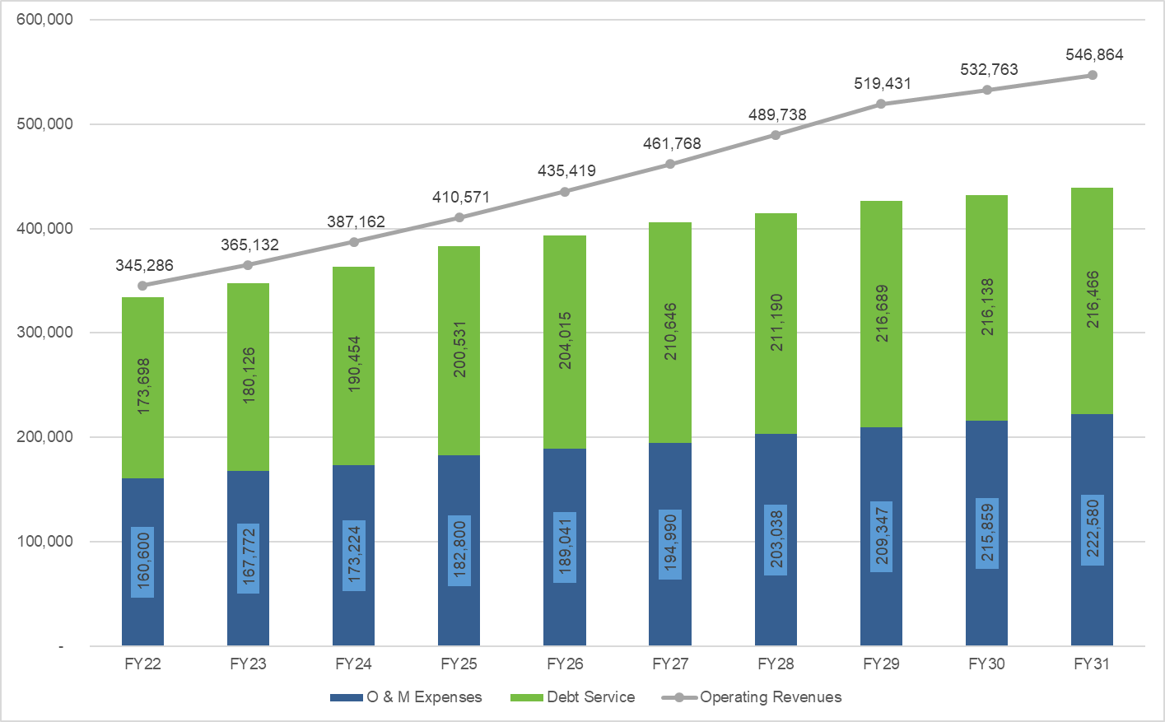

# Debt Management

MSD strives continuously to maintain strong financial performance and bond ratings. The credit ratings on our senior lien bonds remain at Aa3 and AA ratings by Moody’s Investors Service and Standard and Poor’s Ratings Services, respectively.

MSD uses debt to finance its capital program and plans to issue $225 million in revenue bonds during fiscal year 2022 to redeem outstanding commercial paper that has been used as interim funding for capital projects in fiscal years 2021 and 2022.

MSD manages annual debt service expenses by refinancing its long-term obligations when feasible. Our most recent refinancing occurred on September 22, 2020 when we issued $112 million of taxable sewer and drainage system refunding bonds that were used to advance refund the series 2013C revenue bonds. This refunding reduces debt service payment over the next twenty years by $26.5 million.

MSD’s total debt at the end of fiscal year 2021 is $2.4 billion and is projected continue to increase over the next ten years as we invest in rehabilitation of our aging infrastructure and work to address consent decree and regulatory compliance requirements. The chart below summarizes annual debt service and projected total senior debt over the next five fiscal years.

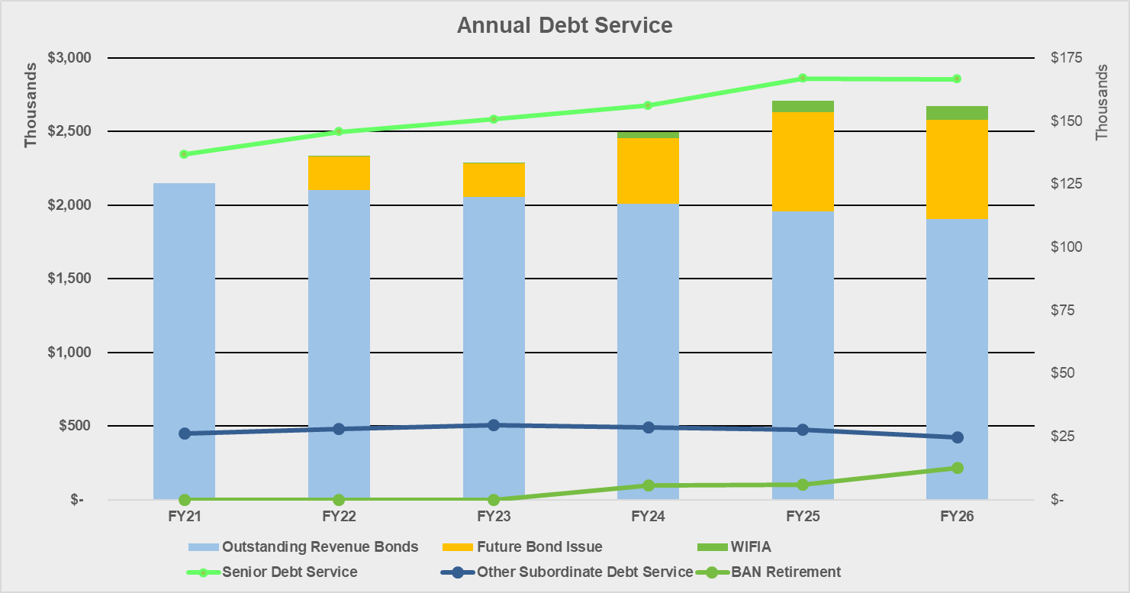

MSD_Logo_2015.eps